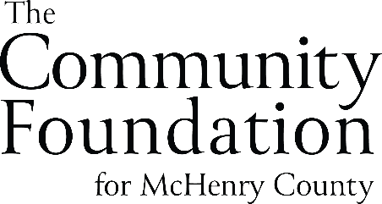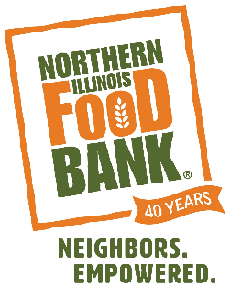
FOR IMMEDIATE RELEASE
Northern Illinois Food Bank Receives Grant from The Community Foundation for McHenry County

Geneva, IL (February 1, 2023) – Northern Illinois Food Bank is pleased to announce it received a $15,000 grant award for two years from the Community Foundation for McHenry County. These funds will be used to support the Food Bank’s food distribution programs.

The Community Foundation for McHenry County works to philanthropically address the needs of McHenry County by providing leadership, granting resources, stewarding assets, and fostering awareness. The Foundation and its community of donors provides financial support and leadership to charitable organizations that serve its residents.

"Because of the generosity of our donors, we are honored to work alongside such organizations like Northern Illinois Food Bank that support the community and social capital of McHenry County," says Jacob Harshbarger, Director of Program Services, The Community Foundation for McHenry County.

“The Northern Illinois Food Bank network serves 18,000 neighbors every month and provides 4.9M meals annually in McHenry County, thanks to the support of our partners like The Community Foundation for McHenry County,” says Maeven Sipes, Chief Philanthropy Officer, Northern Illinois Food Bank. “The Foundation’s grant will help us continue to provide access to nutritious food for McHenry County neighbors experiencing food-insecurity through our network of food pantries, soup kitchens and direct distribution programs reaching vulnerable populations of children and seniors.”

For more information about The Community Foundation for McHenry County, Visit: thecfmc.org.

For more information about Northern Illinois Food Bank, Visit: SolveHungerToday.org.

###
ABOUT THE NORTHERN ILLINOIS FOOD BANK
For the past 40 years, Northern Illinois Food Bank has been dedicated to solving hunger and empowering neighbors. Our vision at Northern Illinois Food Bank is for everyone in Northern Illinois to have the food they need to thrive. A 501(c)(3) nonprofit organization and proud member of Feeding America, we serve our neighbors in 13 counties with dignity, equity and convenience, providing 250,000 meals a day. We bring together manufacturers, local and corporate grocers, area farmers, corporations, foundations, and individuals who donate food and funding, and each week nearly 1,000 volunteers help us evaluate, repack, and distribute food. We also proudly partner with more than 900 food pantries, soup kitchens, shelters, and youth and senior feeding programs to provide nutritious food and resources. Our distribution centers are located in Geneva, Lake Forest, Rockford and Joliet. Find out how you can get help, volunteer, donate or get involved at SolveHungerToday.org, or follow us on Facebook, Twitter, Instagram and LinkedIn.
ABOUT THE COMMUNITY FOUNDATION FOR MCHENRY COUNTY

The Foundation is the leader in McHenry County for providing legacy giving opportunities to our community’s donors and charitable organizations. Founded in 2001 to ensure financial support to McHenry County’s charitable community forever, The Foundation today is an organization that serves to “connect people who care with causes that matter.”
For more information, please call us at 815.338.4483, email us at connect@thecfmc.org or visit our website at thecfmc.org.
For media requests, contact:
Katie Heraty
Media Relations Director
Northern Illinois Food Bank
kheraty@northernilfoodbank.org

